Daily Tip 60 13/08/2003 03:00:00 PM

Combining small values
Sometimes you might want to combine many small, insignificant values before you display the data to a user. This can highlight the larger more significant figures and unclutter reports and graphic legends. In applications where many kinds of data are involved it is advantageous to use generalised techniques to do this.
Below is a macro which can be used to combine small values in a subgrouped bar chart. It can also be easily adapted to work with other data. Additionally, by adding a where clause to the Proc Gchart we could exclude all small values, only charting the large ones.

SAS Code
%macro limit(limit=0.01,
class1=a,
class2=b,
anal=x,
more=.,
in=in,
out=out) ;
* Limit ... values less that this percentage are combined ;
* class1 ... 1st classification variable ;
* class2 ... 2nd classification variable ;
* anal ... analysis variable ;
* more ... value to use for values that are combined ;

proc sql ;
create table &out as
select &class1,
&class2,
sum(&anal) as &anal
from (select &class1,
case when(&anal/sum(&anal)<&limit) then &more
else &class2
end as &class2,
&anal
from &in
group by &class1)
group by &class1,
&class2 ;
quit ;
%mend limit ;

*** Create test data ;
data in ;
do a=1 to 10 ;
do b=1 to 100 ;
x=ranuni(1)*100 ;
output ;
end ;
end ;
run ;

filename graph 'c:\g1.png' ;
goptions device=png gsfname=graph ;
proc gchart data=in ;
vbar a / subgroup=b sumvar=x discrete ;
run ; quit ;

*** Use limit macro to avoid large confusing legends and imperceptibly tiny bar segments ;
%limit(limit=0.02) ;

filename graph 'c:\g2.png' ;
proc gchart data=out ;
vbar a / subgroup=b sumvar=x discrete ;
run ; quit ;

Default Graph produced

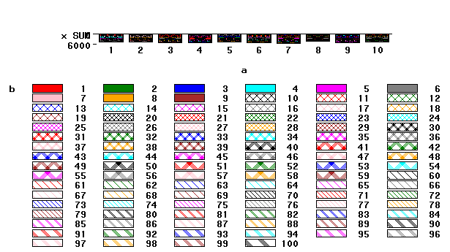Graph with small values combined
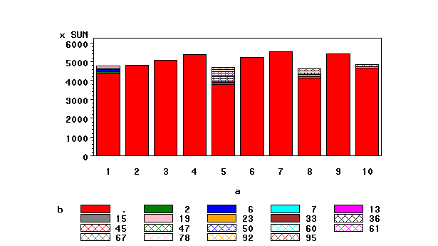

Example tested under SAS 8.2, Windows 2000 by Phil Mason
Wood Street Consultants Ltd. tips@woodstreet.org.uk
www.woodstreet.org.uk
Instant Messengers … ICQ:27165944, AOL:philipamason, MSN: philipandrewmason@hotmail.com, Yahoo: philipandrewmason

